RAI Knowledge Base
Summary: The RAI knowledge base (e.g., the knowledge captured by a knowledge graph) makes meaningful entities and concepts, and their relationships in design, implementation, deployment, and operation of AI systems.
Type of pattern: Product pattern
Type of objective: Trustworthiness
Target users: Architects, developers, data scientists
Impacted stakeholders: RAI governors, AI users, AI consumers
Relevant AI ethics principles: Human, societal and environmental wellbeing, human-centred values, fairness, privacy protection and security, reliability and safety, transparency and explainability, contestability, accountability
Mapping to AI regulations/standards: ISO/IEC 42001:2023 Standard.
Context: The ecosystem of AI systems involves broad ethical knowledge, such as AI ethics principles, regulations, and guidelines. Such ethical knowledge is scattered and is usually implicit or abstract to end users or even developers and data scientists who primarily do not have a legal background and focus more on the technical aspects of AI systems.
Problem: The content of some regulations is not easy to understand and interpret by stakeholders who do not have a legal background. This results in negligence or ad hoc usage of relevant ethical knowledge in AI system operation. How can stakeholders apply ethical knowledge to the operation of AI systems? How can we make AI systems compliant with high-level principles and regulations?
Solution: A knowledge graph is a technology that represents entities in the real world, like objects, situations, concepts, or events, and the relationship between the entities. Knowledge graphs have been used to achieve explainable AI in different AI fields.
A knowledge graph–based RAI knowledge base makes meaningful entities and concepts and their relationships in design, implementation, deployment, and operation of AI systems. With the RAI knowledge base, the rich semantic relationships between entities are explicit and traceable across heterogeneous high-level documents on one hand and different artifacts across the AI system lifecycle on the other hand. Thus, RAI requirements of the AI system can be systematically accessed and analyzed using the RAI knowledge base [1].
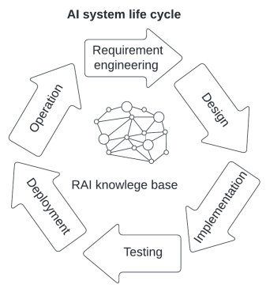
Fig.1 RAI knowledge base
Benefits:
- Compliance checking: The RAI knowledge base is extracted from the regulatory document and high-level principles. The knowledge graph provides structured data for stakeholders to employ compliance-checking solutions.
Drawbacks:
- Increased development effort: Building a correct and efficient knowledge base through natural language processing is time-consuming and error prone.
Related patterns:
- Continuous RAI validator: RAI knowledge base could be an input of continuous RAI validator.
- RAI digital twin: RAI digital twin could be built based on the RAI knowledge base.
- RAI governance of APIs: RAI issues of APIs can be detected by RAI knowledge base.
Known uses:
- Awesome AI guidelines aims to provide a mapping between ecosystem of guidelines, principles, codes of ethics, standards and regulation around artificial intelligence.
- The responsible AI community portal is provided by AI Global, which is an evolving repository of reports, standards, models, government policies, datasets, and open-source software to inform and support responsible AI development.
- Responsible AI knowledge-base is a knowledge base of different areas of using and developing AI in a responsible way.
Reference
[1] Naja, I., et al. A semantic framework to support AI system accountability and audit. in European Semantic Web Conference. 2021. Springer.

